T5

Internet



Dandelion app



Local access point



T5

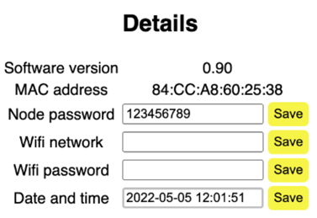

Network: Dandelion

Default password: 123456789

Use IP address shown on T5 display

Web browser

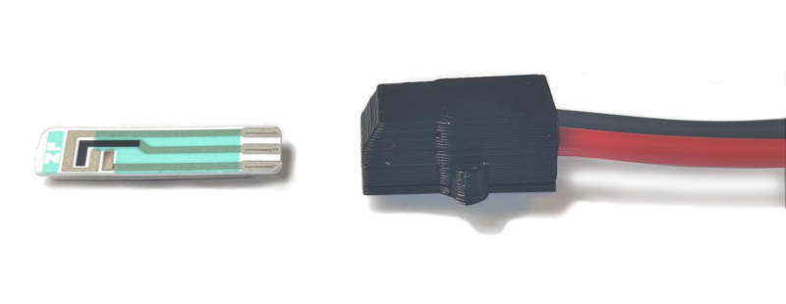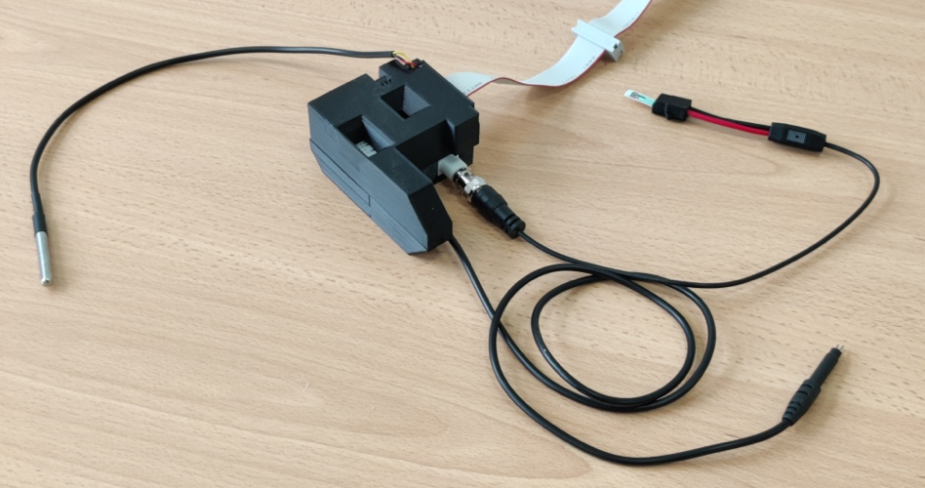

Substrate temperature probe

Light intensity sensor

pH probe

Air temperature and humidity sensor

Electrical conductivity probe

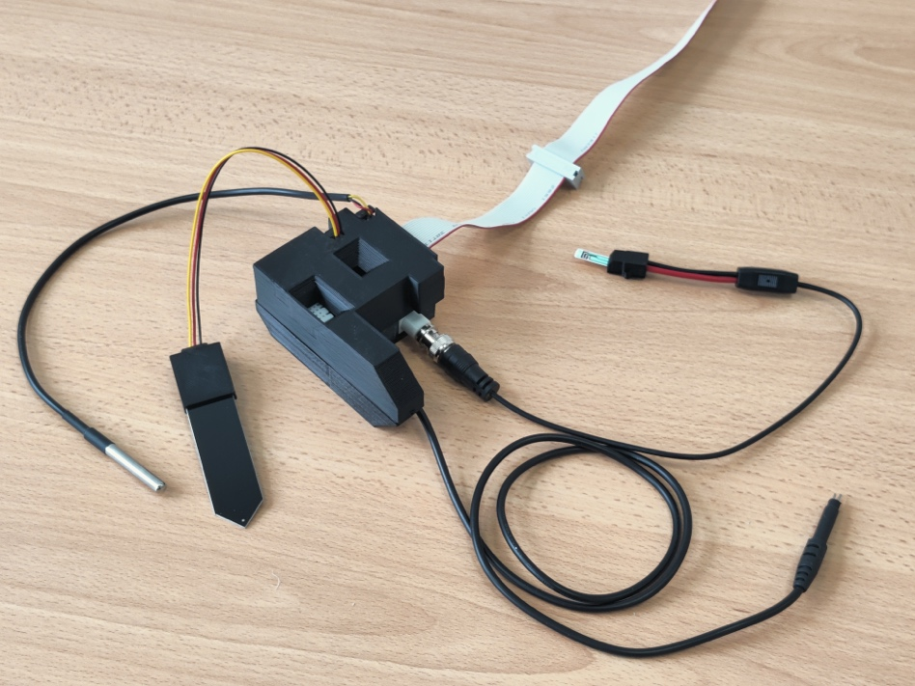

Substrate temperature probe

Light intensity sensor

pH probe

Air temperature and humidity sensor

Electrical conductivity probe

Moisture probe

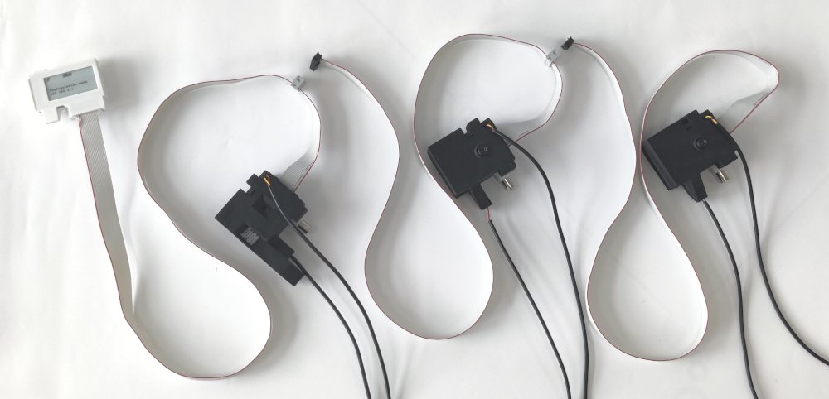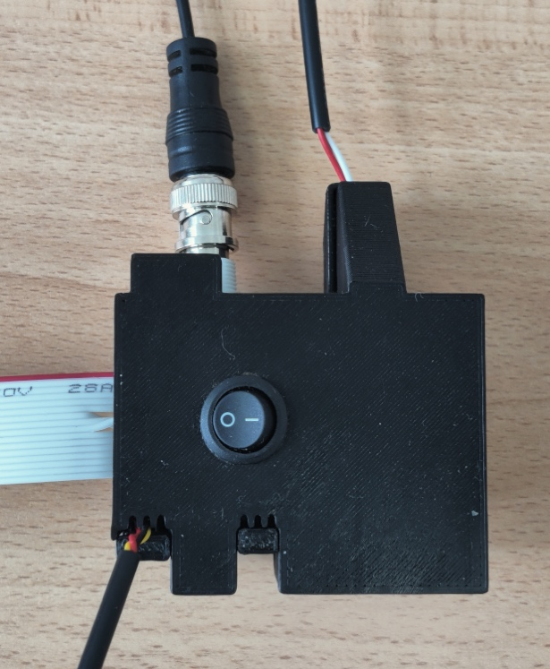

pH probe

EC probe

Temperature probe

Sensor selection switch

